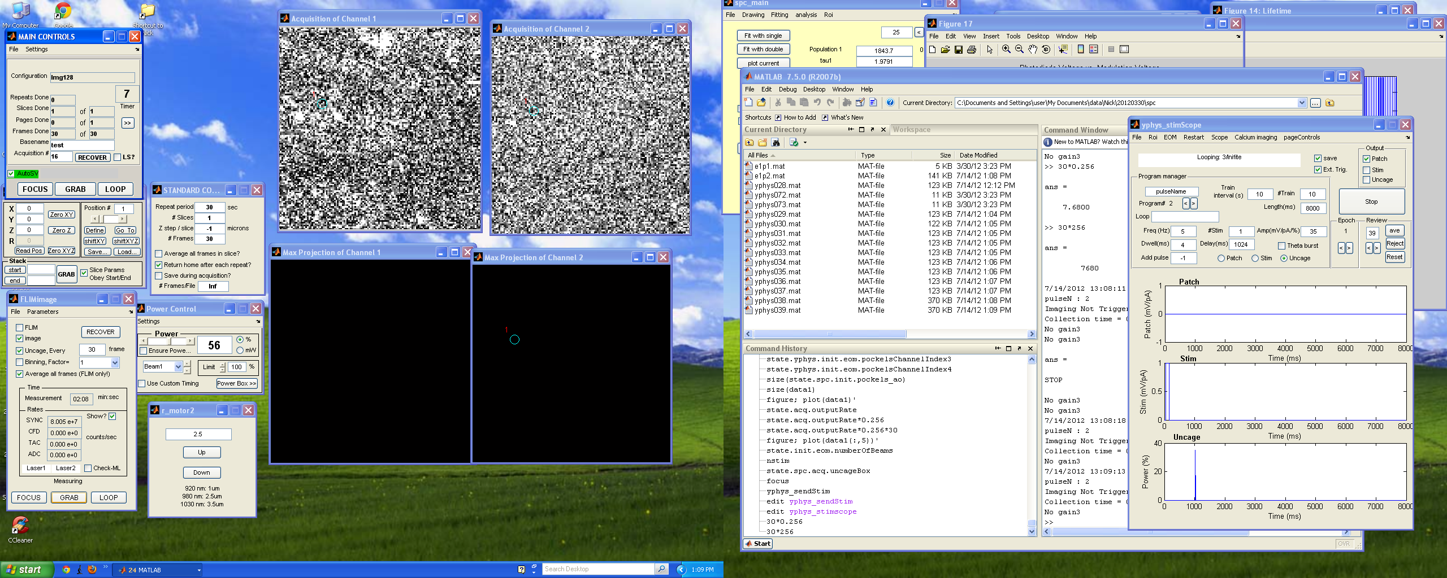
**Imaging + Uncaging****
1 In FLIMimage window enter the same number of frame for “Uncaging, every” = for example 30 frame”as (#Frames = fe30) as in the Standard Control.
- Mark on “Image” and “Uncage, Every”
- Mark off “FLIM” and “Binning factor=”
- in Standard Control Mark off “Average all frames in slice”
In Yphys_stimScope wondow
- setup “Length (ms)”= frametime (fe256) x #frames(fe30) = 7680 (make it 8000)
- set Amp % for light power uncaging =fe 35
- #train =fe10
- train interval =fe10
- #stim =fe1
- dwell (ms = fe4
- add pulse =fe-1
- delay(ms)=#fraimes before uncaging (fe4) * fraime length (fe256) = 1024
- mark “on” “uncage” ( Do not mark “uncage” in the output!!!)
- In the output you can mark “stim” if you what also stim!

**For Imaging + Uncaging + ephys recording****
yphys_stimscope
(Output)
Mark on “Save” “Ext Trig” and (“Patch” or “Stim”).
Off “Uncage”

Loading Yphys data
load('yphys032.mat')
yphys032.data

Or
Open in yphys_stimscope (fig 10; file >open file >file name)
global yphys
yphys.data.data
Yphys data analysis

run
value = Nick _Analysis
figure; plot (value)

